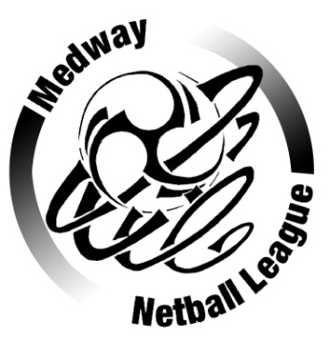 MEDWAY NETBALL LEAGUE

Respect in Netball

To All Team secretaries, Umpires and Players

Please continue to support and respect our umpires and players alike. We urge you to consider contacting umpires prior to games to avoid double booking and or when games are conceded. This will help teams to get umpires in the future.

The following will not be tolerated

- Swearing and Abusive language by players, officials or spectators during play or around the courts
- Threatening and intimidating behaviour
- Inappropriate comments and questioning of umpires during play with regards to their decisions
- Lack of respect from all and unsporting remarks
- Lack of discipline on court by players

Players and Spectators are entitled to hold an opinion of umpires however they are not allowed to voice this opinion in the form of questions or abuse during a match. If clarification of a rule is required then the appropriate team captain can approach the umpire at the end of any quarter.

As many players admit, they would not like to umpire themselves therefore it is even more important that we do not lose those we already have. Your umpire should be thanked at the end of each match, we cannot play without them!

Please ask your umpire for clarification at the beginning of your match if you are not sure of any rule.
Umpires do not claim to get it right all of the time.

The League has a formal complaints procedure as detailed in the Constitution and Rules and would request that where possible you should put your complaint in writing to Mrs Pauline Alderman the complaints secretary.

Unsporting and dangerous play should be addressed at the time by the umpire.

As a league we wish to set a strong example of fair play and to keep Netball as high profile as we can, it is a sport we all love and want to ensure that all participants enjoy.

Medway Netball League

