Medway Junior Netball League Newsletter
December 2023

The Christmas season is fast approaching and with it some very cold and wet weather. To date we have lost two playing Saturdays, and we hope that the weather is kinder to us in the coming weeks and months. From 6 January 2024, games will start slightly later to allow for the courts to defrost should the weather be very cold. The fixtures reflect the later start times for January and February with session 1 starting with training at 9.25am, games beginning at 9.50; and session 2 starting with training at 10.40 with games starting at 11.05am. We hope everyone will be away by noon at the latest. Coaches have been notified of dates for the rearranged games and should we have more adverse weather we will need to consider how best to get the games played. We will keep everyone updated.
The last newsletter promised a box of chocolates for the first team to send us something for this newsletter. Thanks to the Platinum minis team for sending in this photograph (permissions received) who are playing in Division 2 and who are currently topping the league with 28 points. You will be receiving your box of chocolates very shortly.

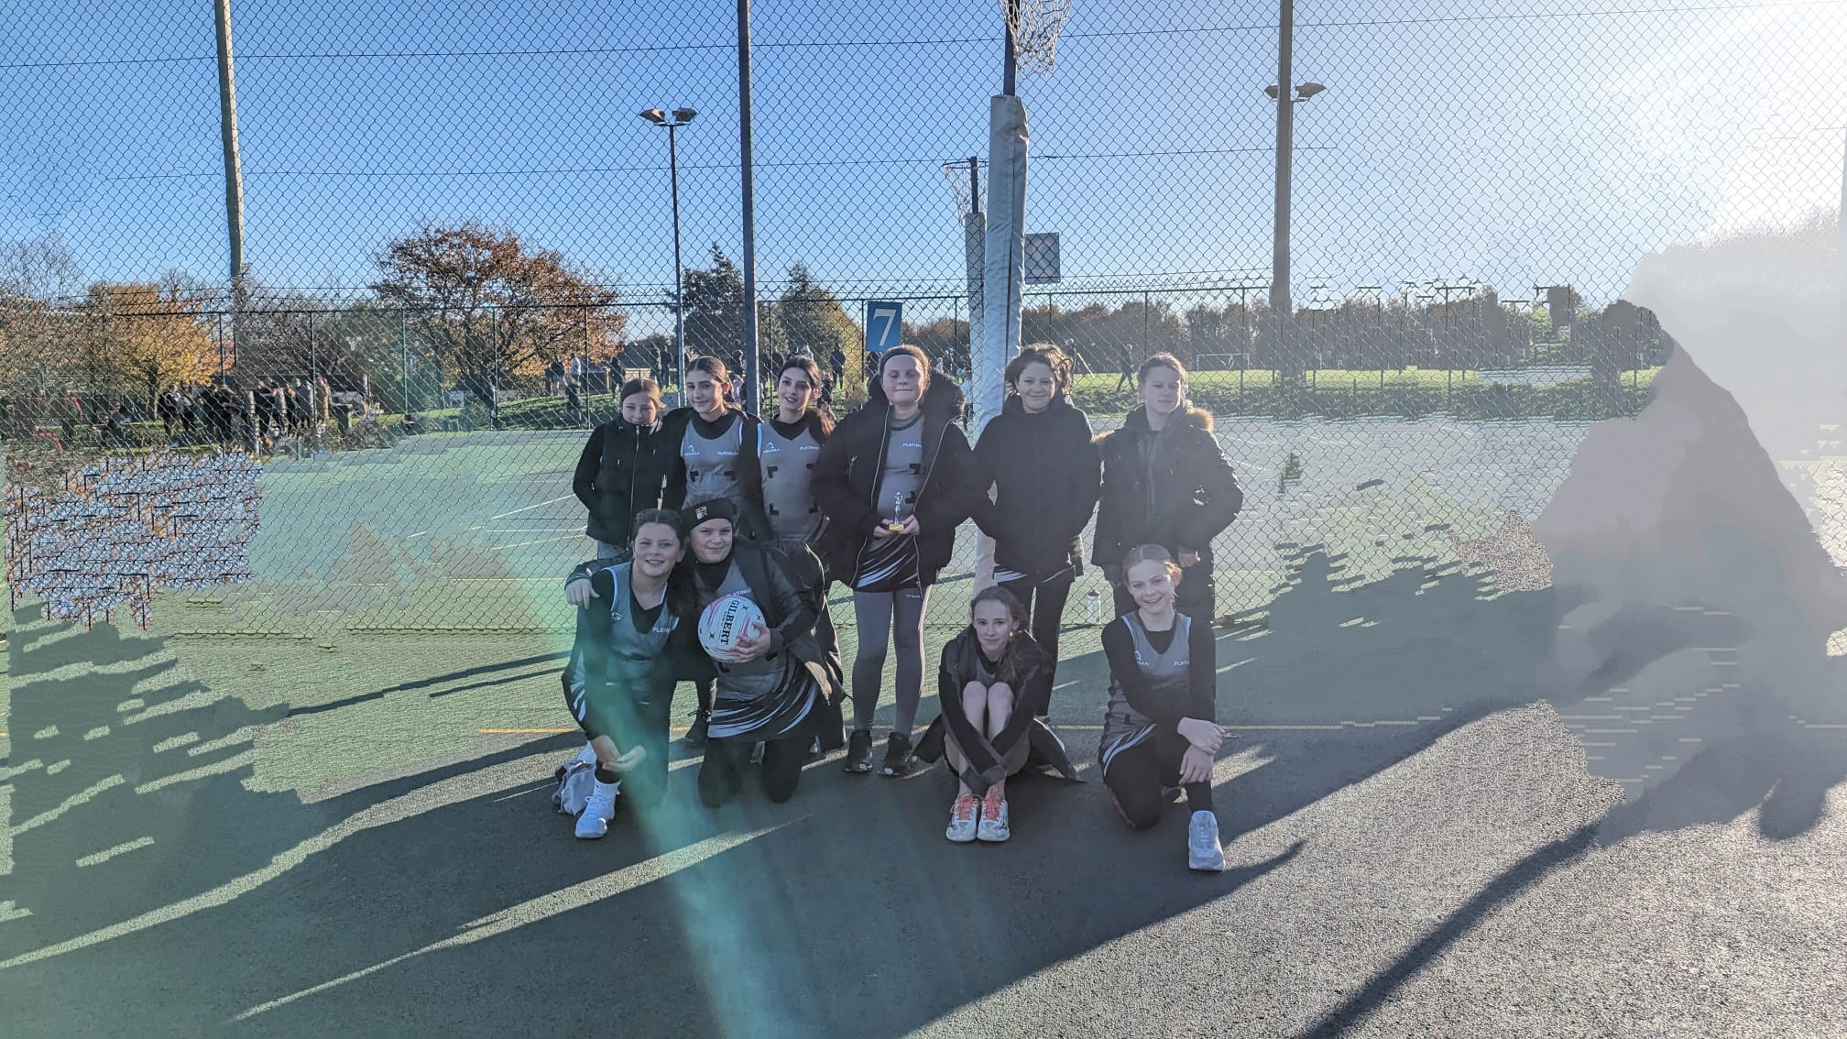

Thanks also to Topaz minis who are new to playing in Division 2 this season and are here modelling their new kit. Chocolates for them too!
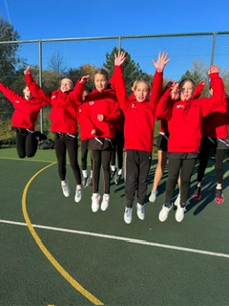
The last newsletter signalled that we would be running a 12 days of Christmas Raffle and we are true to our word. On 16 December we hope we can all have some festive fun and raise some money for our chosen charities, Cleft lip and Palate Association Cleft Lip & Palate Association (clapa.com) and Pancreatic Cancer Pancreatic Cancer UK - For Everyone Affected by Pancreatic Cancer
The Committee really appreciates how the cost of living crisis is affecting most people and are grateful for whatever people and families can give to these causes. Thank you. We will be collecting in the following ways:
- Raffle tickets at £1 a strip will be available from this Saturday, 9 December from the pavilion. This is a 12 days of Christmas raffle – 12 prizes reflecting the themes from the song! No idea what the prize for 9 ladies dancing will be. The draw will take place on Saturday 16 December.
- For a small donation of £1 players, coaches, umpires can don their best festive leggings, jumpers, hairbands etc. Please remember players need to abide by the netball dress code but that does leave lots of scope for festive fun! We will run this on Saturday 16 December but if your team has a bye on that day then please feel free for the players to wear their festive outfits for a small donation on 9 December. Remember no one should be excluded should they not be able to donate the fee.
- We are not looking for a set donation but if each team donated £7 from festive leggings/raffle tickets, we would raise just over £180 which would be fantastic. Please let your parents and spectators know. Thank you.
Wellbeing fund – the Committee has a wellbeing fund and coaches should have received information about how to access. Please contact your divisional representative should there be any questions.
STATISTICS
- Since September, 3397 goals have been scored – amazing girls – well done!
- The Premier division has seen most goals scored at 1072 with Crystals the top of that division, although they don’t have the most goals.
- Division 2, with only 5 teams and 3 new teams have scored 611 goals which is a great achievement.
- Titans in the Intermediate division have scored the most goals to date with 275. Congratulations!
- Division 1 have three teams close on points – Pink Diamonds, Jets and Macklins Minis. All to play for.
The league is proud of the work we do to offer young players the opportunity to play netball in a safe environment. The Emeralds section of the league is thriving with 55 girls from 5-12 years currently training on a Saturday morning. Our aim is to get the girls to a standard to enter the Junior League and enjoy playing competitively. There are teams in all divisions of the current league who started out as an Emerald!
This year we have taken on a few younger girls in the Gym, they love the "game" at the end of the session, but it does seem like organised chaos at times! We are hoping to have two teams joining the League in the Spring 2024. Pink Crystals have been with us since they were very young; they played in the last rally and are really looking forward to playing outside. Our other new team will be made up from slightly older girls who have only recently started playing netball but are showing great promise. Any queries about Emeralds, please e mail issy26@hotmail.co.uk
We have also asked two experienced coaches to try and build another team of older girls who are interested in playing competitive netball. We hope we will be able to build a team who can enter the league very shortly. We all have lots of enthusiasm and don’t want to turn any players away, but we are almost at capacity unless we can recruit some more coaches. If you are interested in becoming a coach, please contact any member of the Committee or speak to someone at the Desk on a Saturday.
Committee members have been walking the courts on a Saturday morning wearing pink high viz vests. This initiative has proved helpful in diffusing any minor issues that can arise during the games. Please do ask for support if needed as they walk the courts.
UMPIRING
From January 2024, we will be looking to support our under 18 umpires more who will be wearing green armbands. The slogan is Green is Teen and whilst no umpire, regardless of age, should face any abuse or unreasonable challenge, we must remember that our young umpires are only children and need everyone’s full support.
Our umpire programme is essential to the success of the league. No umpires, no matches. If there is anyone out there that wants to give umpiring a go, coaches, or parents, please make contact with Michelle Ray who will be holding open sessions in March 2024.

Finally, the MJNL Committee would like to wish everyone a happy festive season. Whatever you all get up to enjoy yourselves, keep safe, have a break from netball and we look forward to seeing everyone fit and well early in 2024….. although we do have two weeks of matches left in 2023.
MNL December 2023
RGS is a non-smoking and non-vaping site and also a dog free site - guide dogs the exception. Please park responsibly

