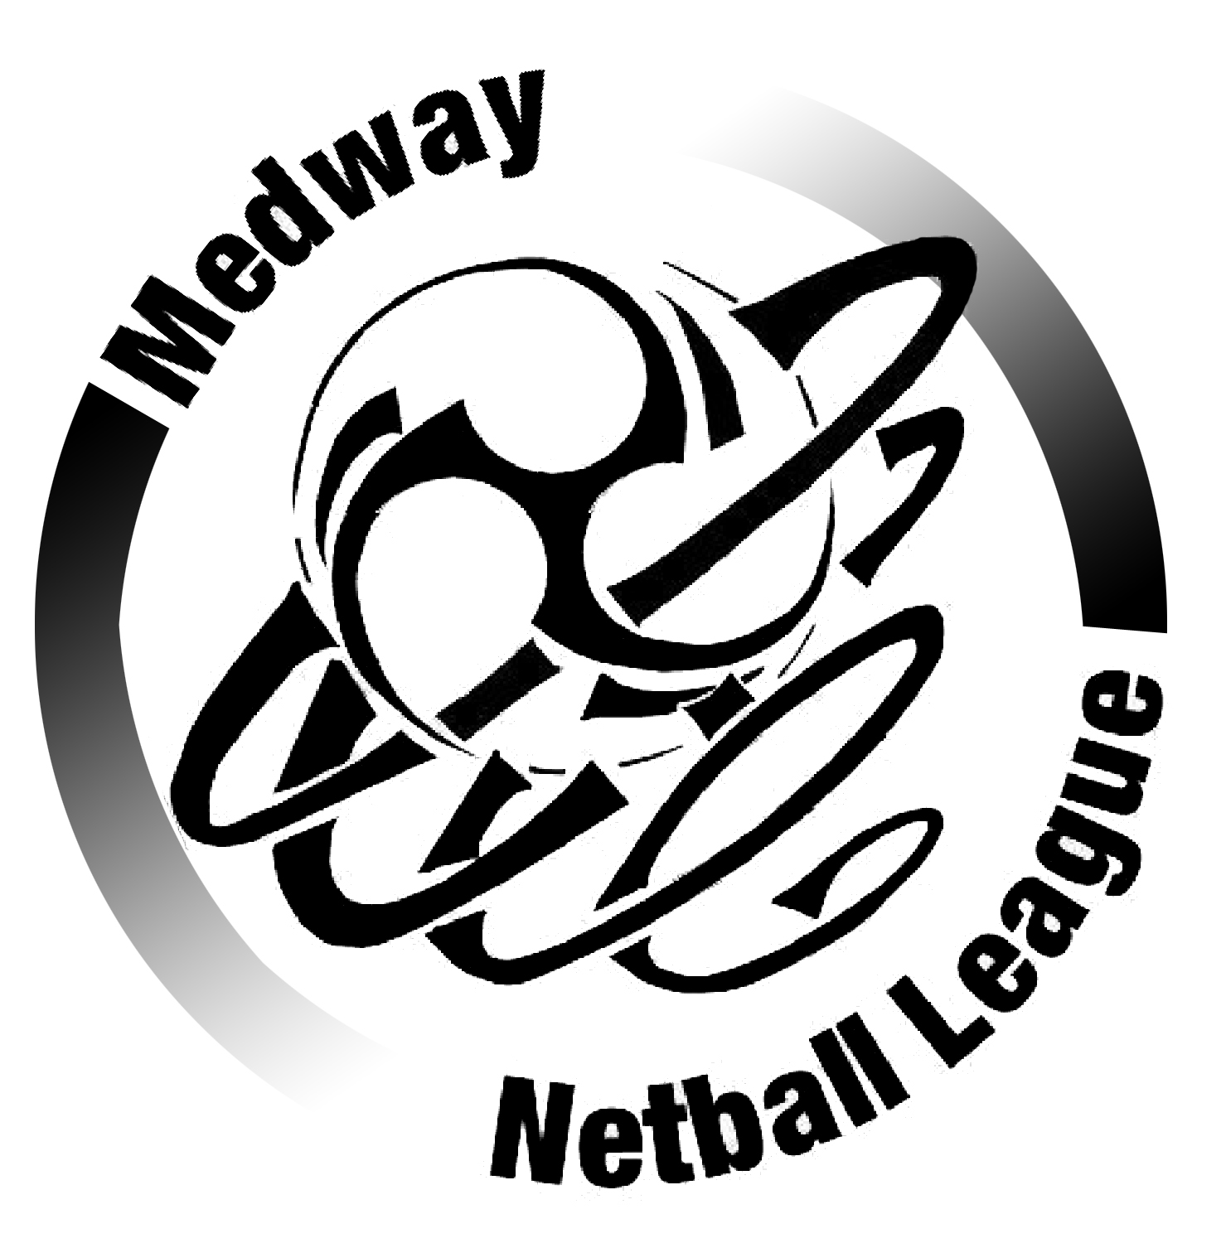
MEDWAY NETBALL LEAGUE Registration Card – Summer/Winter

Team Name: -----------------------------------------------

Member’s full name:-----------------------------------------------------------------

Player’s EN Membership No. -----------------------------------------------------

Players must have reached the age of 14 years to be eligible to play. If under 18 years of age an EN Age Banding form shall be completed.

DATA PROTECTION: We will not pass this information to any third party or use it for any other purpose than indicated in the Privacy Notice below. We will collect and process all personal data in line with the General Data Protection Regulation 2018.

Please be advised that the A.G.M. is held in October. All individuals are welcome. Any team not represented will be ineligible to play as a team collectively or part thereof for one season. See Constitution Rule 10 AGM. In playing in the MNL I also agree to abide by the rules of the Constitution & Summer Rules.

Member’s
Acknowledgement and Signature------------------------------------------

Date: ----------/----------/ 20

Secretary’s Signature ---------------------------------------------------------

A new player registering on the day of a match must have her player registration counter-signed by her Captain and other team Captain or either Umpire, before the match commences.

Privacy Notice (How we use your information)

The categories of information that we collect, process, hold and share include:

- Name
- Contact Information
- England Netball membership number
- Date of birth

Why we collect and use this information - We use your data to:

- Enable us to register and check you are registered as a Medway Netball League player or umpire
- Enable us to check you are members of England Netball
- To check that you are eligible to play in the Medway Netball League
- To check that you are eligible to umpire in the Medway Netball League
- To send you information that is relevant to you for the purposes of playing, umpiring, coaching, administration in the Medway Netball League.
Who we share this information with
We share contact information for committee members, team contacts, umpires and coaches with other members of the Medway Netball League.
We may also share information with Kent Netball in relation to complaints, umpiring and coaching courses, also with England Netball regarding any membership queries.

Storing this information
We hold your data for the entire time that you may be in an umpiring, coaching, committee or life president role in the Medway Netball League and for the EN membership year period for players and team members.

Further information
If you would like further information about this privacy notice, please contact Hazel Skinner, Secretary Medway Netball League.

Version 8 – August 2026
MEDWAY NETBALL LEAGUE
Registration Card – Summer/Winter

Team Name:-------------------------------------------------

Member’s full name: ---------------------------------------------------------------

Player’s EN Membership No. ----------------------------------------------------

Players must have reached the age of 14 years to be eligible to play. If under 18 years of age an EN Age Banding form shall be completed.

DATA PROTECTION: We will not pass this information to any third party or use it for any other purpose than indicated in the Privacy Notice below. We will collect and process all personal data in line with the General Data Protection Regulation 2018.

Please be advised that the A.G.M. is held in October. All individuals are welcome. Any team not represented will be ineligible to play as a team collectively or part thereof for one season. See Constitution Rule 10 AGM. In playing in the MNL I also agree to abide by the rules of the Constitution & Summer Rules.

Member’s
Acknowledgement and Signature ------------------------------------------

Date: -------/---------/ 20

Secretary’s Signature ---------------------------------------------------------

A new player registering on the day of a match must have her player registration counter-signed by her Captain and other team Captain or either Umpire, before the match commences.

Privacy Notice (How we use your information)

The categories of information that we collect, process, hold and share include:

- Name
- Contact Information
- England Netball membership number
- Date of birth

Why we collect and use this information- We use your data to:

- Enable us to register and check you are registered as a Medway Netball League player or umpire
- Enable us to check you are members of England Netball
- To check that you are eligible to play in the Medway Netball League
- To check that you are eligible to umpire in the Medway Netball League
- To send you information that is relevant to you for the purposes of playing, umpiring, coaching, administration in the Medway Netball League.
Who we share this information with
We share contact information for committee members, team contacts, umpires and coaches with other members of the Medway Netball League.
We may also share information with Kent Netball in relation to complaints, umpiring and coaching courses, also with England Netball regarding any membership queries.

Storing this information
We hold your data for the entire time that you may be in an umpiring, coaching, committee or life president role in the Medway Netball League and for the EN membership year period for players and team members.

Further information
If you would like further information about this privacy notice, please contact Hazel Skinner, Secretary Medway Netball League.

Version 8 – August 2026

